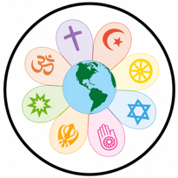

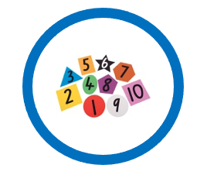
RE

In RE we will be learning about…

- How are Hindu beliefs expressed in artefacts and worship?
- How does sacred text help Hindus understand Dharma?
English

In Spring term, the books we will be looking at are…

- Curiosity by Markus Motum
- Farther by Grahame Baker-Smith

The types of writing we will be covering are…

- A formal mission report
- A setting narrative

In Maths this term we will be focusing on…

- Place value
- Addition and subtraction
- Multiplication and division
- Fractions

Mathematics



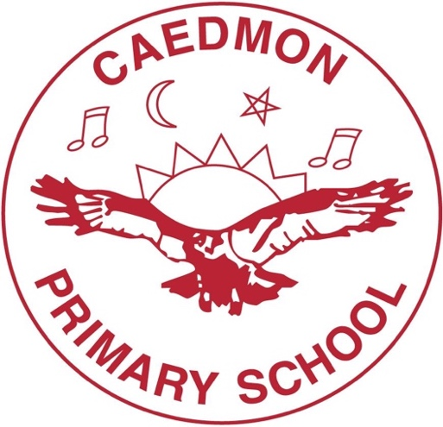

In Science we will be learning about…
- Materials
- Space

The skills we will be covering are…
- Asking questions and making predictions
- Setting up tests, observing and measuring and recording data
- Interpreting results and evaluating enquiries

In PSHE we will be learning about…

- Computer/online safety (image sharing)
- Keeping/staying safe (peer pressure)
- Keeping/staying healthy (smoking)

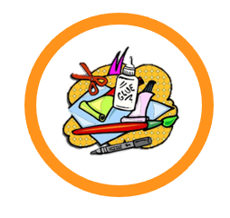



Physical Education

In Art we are learning to paint.

For our DT topic, we will be learning about mechanisms.

PSHE
Science
History and Geography
Art and DT
Year 5 Autumn Term

In our PE lessons we will be learning how to:

- Swim (Tuesdays)
- Play tag rugby (Wednesdays)

In History our topic is The Tudors. We will be learning about…

- The influence of Tudor monarchs on both British society and the wider world
- Major Tudor rulers, how they shaped religion, trade, exploration, and law, and how their decisions had long-term consequences across the globe

In Geography we will be looking at…

- Our local area
- Land use and how it has changed over time
- Reasons for changes in land use

