In our adult led tasks we will be:

- Sharing our stories – The Colour Monster and Little Glow
- Talking about our experiences of celebrations.
- Beginning to mark make using a range of resources.
- Drawing pictures.
- Singing nursery rhymes
- Listening to a range of stories with props and puppets
.

In our play we will also be able to:
.
- Draw pictures.
- Sharing stories with our friends.
- Using role play to share our experiences and create our own stories.
.

In our adult led tasks we will be:

- Beginning to recognise numerals
- Counting children who are in the session.
- Singing number songs and nursery rhymes with puppets and props.
- Using different shaped marks and comparing them.
- Learning about common shapes.

In our play we will also be able to:
- Recognise numbers in the environment.
- Use our counting skills.
- Begin to make marks that represent.

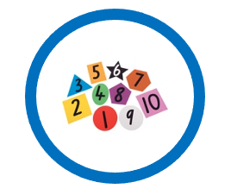



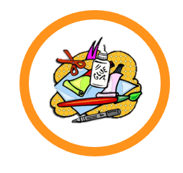




In our PE lessons we will be learning how to:

- Move safely in an area when others are moving too.
- Throwing and catching.
- Games
We will also enjoy:
- Yoga
- Dough disco
- Dancing

In our play we will be:
- Developing our big and small drawing and writing movements
- Using tools – scissors, lego, tweezers etc
- Building our strength when climbing.
- Riding bikes.

Physical Development

Our communication will be developing all the time.

In particular, we will be:

- Talking about our experiences at home and with our families.
- Listening to our friends at circle time, in group times and in our play.
- Talking about what we are planning to do in our choosing time.
- Using language from our story and learning new words.

Emotions
And
Celebrations

Communication & Language
Expressive Arts & Design
Understanding the World
Personal, Social & Emotional Development

Our days in Nursery will be great for building our confidence and
developing our friendships.

To develop our PSED, we will be:

- Beginning to show more awareness of our daily routines.
- Supporting our new friends when they join Nursery.
- Following our classroom rules.
- Beginning to find ways to solve problems with our friends.
- Sharing our toys.
- Taking turns with our friends.
- Playing with our friends.
- Sharing our emotions.
Mathematics
Literacy

In Nursery we love to spend time being creative. We will be busy with lots
of these activities:

- Experimenting with ways to change materials by cutting, sticking, folding and tearing.
- Drawing and colouring
- Using tools to roll, cut and mark make in the play dough.
- Using different types of paints and a range of tools to make pictures.
- Singing our favourite nursery rhymes.
- Learning new songs and performing our favourite nursery rhymes.

To find out more about the world around us we will be:

- Finding out about different festivals including Halloween, Diwali, Bonfire Night, Christmas, Eid.
- Talking about our home experiences with My Special World
- Sharing our family traditions during celebrations.
- Learning the days of the week
- Learning about the season of autumn

