In our adult led tasks we will be:

- Sharing our stories – Home Sweet Home and Let’s Get Growing
- Talking about our experiences of home life.
- Drawing our homes and the people in them.
- Writing our name and some letters.
- Begin to recognise RWI picture cards
- Draw and write on paper, on screen and on different textures, such as in sand or playdough
- Distinguishing between the different marks they make

In our play we will also be able to:
- Draw pictures and gives meaning to marks
- Sharing stories with our friends.
- Using role play to share our experiences and create our own stories.

`

In our adult led tasks we will be:

- Recognise numbers in our environment
- Write numbers
- Match numerals and amounts
- Count children who are in the session.
- SIng number songs and nursery rhymes.
- Use shapes to create pictures

In our play we will also be able to:
- Recognise numbers in the environment.
- Exploring puzzles and jigsaws
- Representing numbers by marks.



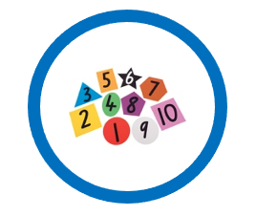



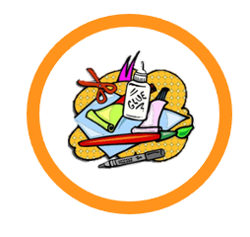


In our PE lessons we will be learning how to:

- Move safely in an area when others are moving too.
- Throwing and catching.
- Games
We will also enjoy:
- NUFC sessions
- Dough disco
- Gross motor dancing
- Climbing and jumping

In our play we will be:
- Show increasing control of fine. And gross motor Manipulate small objects
- Developing our big and small drawing and writing movements
- Using tools – scissors, lego, tweezers etc
- Building our strength when climbing.
- Riding bikes.

Physical Development

Our Nursery environment and tasks are steeped in
Communication and language opportunities

In particular, we will be:

- Talking about things we do at home
- Working on our attention skills during circle time games
- Listening and talking during circle and planning time
- Using language from our story and learning new words.

Home
Sweet
Home

Communication & Language
Expressive Arts & Design
Understanding the World
Personal, Social & Emotional Development

Our days in Nursery will be great for building our confidence and
developing our friendships.

To develop our PSED, we will be:

- Talking about our feelings
- Continue to develop our friendships and relations with peers and adults
- Supporting our new friends when they join Nursery.
- Following our classroom rules.
- Beginning to find ways to solve problems with our friends.
- Sharing our toys.
- Taking turns with our friends.
- Playing with our friends.
- Sharing our emotions.
Mathematics
Literacy

In Nursery we love to spend time being creative. We will be busy with lots
of these activities:

- Role playing in our home corner, jobs shed and café
- Experimenting with ways to change materials by cutting, sticking, folding and tearing.
- Drawing and colouring
- Explore musical instruments
- Using tools to roll, cut and mark make in the play dough.
- Using different types of paints and a range of tools to make pictures.
- Singing our favourite nursery rhymes.
- Learning new songs and performing our favourite nursery rhymes.

To find out more about the world around us we will be:

- Talk about our home lives.
- Making bird feeders and talking about wildlife and nature
- Planting seeds, making predictions and observations
- Role playing familiar situations
- Talk about our ‘My Special World’ experiences

